1
The application is filled out via tsl.se by the terminating company, the union or the outplacement company and gets
a TSL number.

2
TSL checks that the terminating company has joined the insurance scheme.

3
The outplacement company contacts the terminating company and the union to get the details about the individuals that will participate.
8
At the second individual meeting the person who has been dismissed will decide whether to participate in the outplacement program and will then sign the individual statement.

'\

7 t
The persons who have been dismissed have their first individual
meetings with the coach and are informed about the requirements for the program.

6
A decision is sent by e-mail to the terminating company, the union and the outplacement company.

9
The outplacement company scans and e-mails the individual statement to TSL.

'\

10
Once TSL has received the individual statement the outplacement company can determine a start date for the dismissed.

'\
11
The outplacement company enters the start date in TSL's extranet and may subsequently send the first invoice.

12
The outplacement program is then implemented.

13
No later than 12 months after the last day of employment, the outplacement company will report to TSL on the progress of the dismissed person.
'\

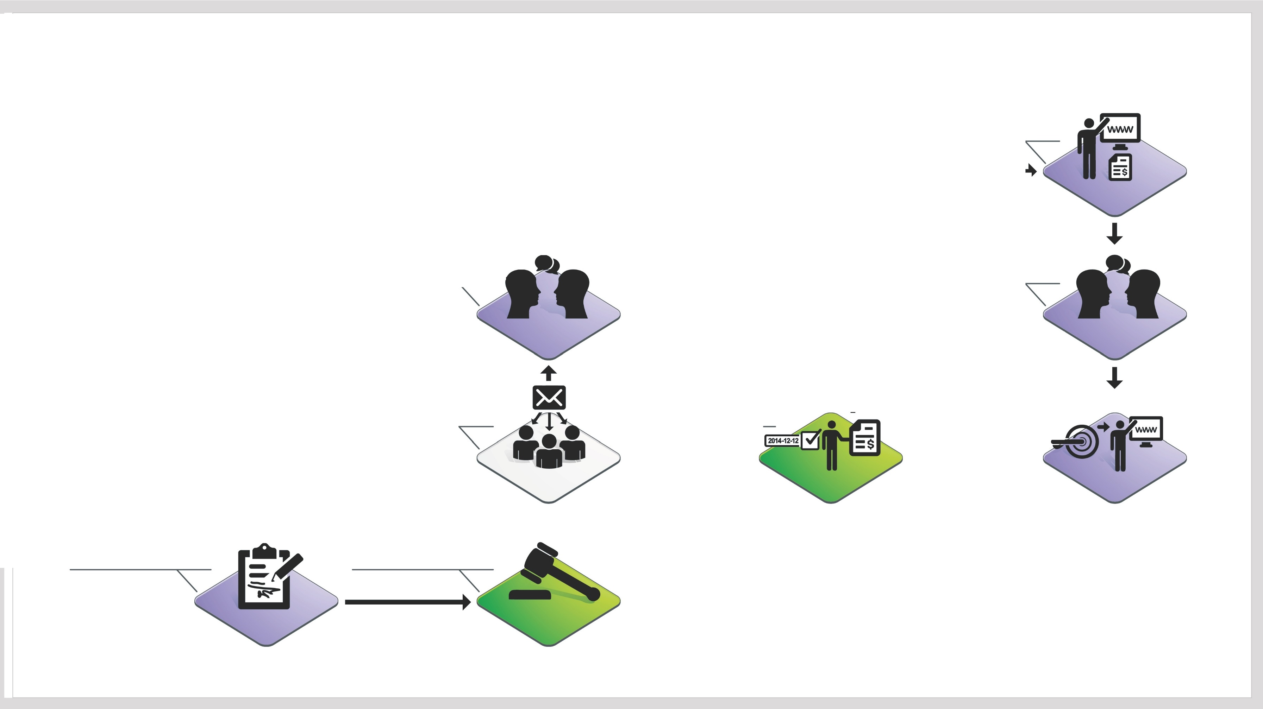
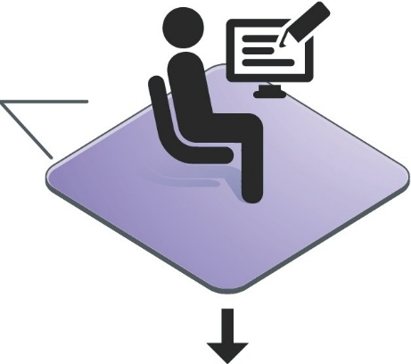
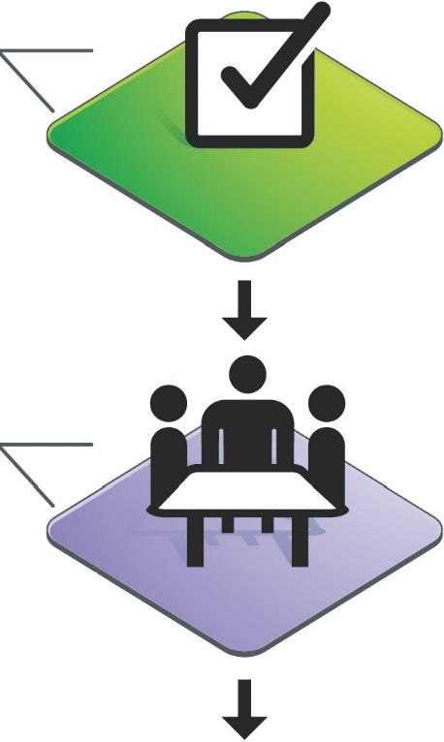
4
The outplacement company makes a list of participants. After being signed by the terminating company and the union it is sent to TSL.
5 t
TSL processes and makes decisions based on the list of participants.

